# **Development of a graphical User Interface that calculates that performs Image Processing using Matlab’s Image Processing Toolbox**

## Clients

Mapua University, Self Made Project for Electronics Laboratory

## Objective / Goals / Purpose

To create a GUI using MATLAB’s Graphical User Interface Development Environment (GUIDE) to:

* Perform Image Processing techniques to an imported image using Matlab’s Image processing toolbox. The following are the techniques that are available to the user:
  + Image Contrast adjustment,
  + Subtraction of the Background image from original image
  + Threshold of the image
  + Intensity Image
  + Indexed image
  + Binary image
  + RGB image
  + Morphological opening
  + Multi-frame image
  + FIR filter
* Allow the user to vary/configure settings of each image processing technique in the GUI, making each feature more variable.

## Technologies Used

MATLAB GUIDE, C/C++

## Description

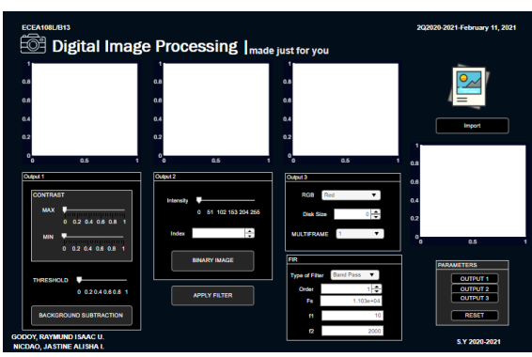

This project uses a Graphical User Interface (GUI), allowing users to design and control the software application through point-and-click interactions. GUI operating systems are more user-friendly because they don't require memorization of commands or programming knowledge. When programming the GUI, "Guide" automatically generates an M-file that manages the GUI's operations. This M-file initializes the GUI and provides a framework for all the GUI callbacks, which are the commands executed when a user interacts with a GUI component. Using a code editor (M-file editor), additional code can be added to these callbacks to perform specific functions.

The project's GUI will display the following outputs:

1. Image contrast adjustment, background subtraction, and image thresholding for the first output.
2. Intensity image, indexed image, and binary image for the second output.
3. RGB image, morphological opening, multi-frame image, and FIR filter type for the third output.